Create Node-RED Service

|  |  |
| --- | --- |
|  |  |
| Team ID | PNT2022TMID28961 |
| Project Name | Gas leakage monitoring and alerting system for industries |

**Aim**:

To create a web application, create a Node-RED service.

# Steps to be followed

Step 1: Navigated to the App creation page.

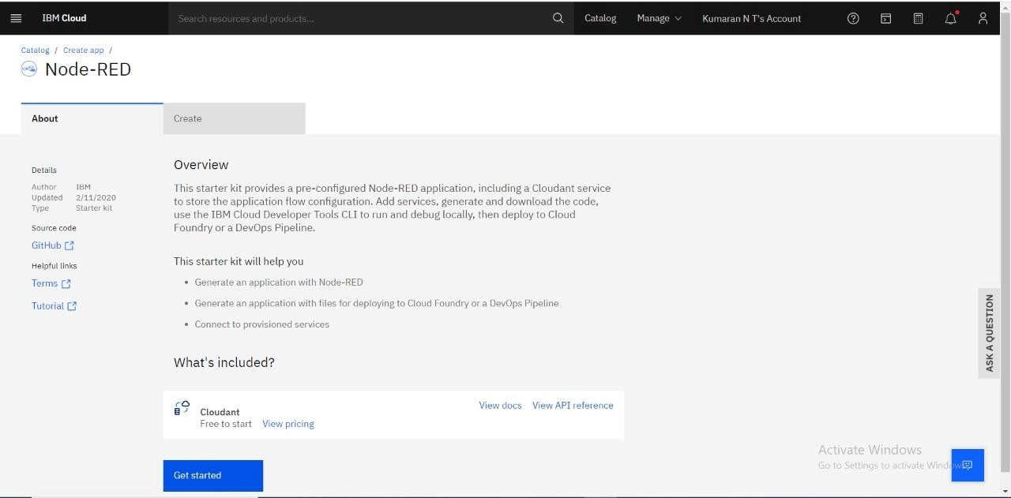

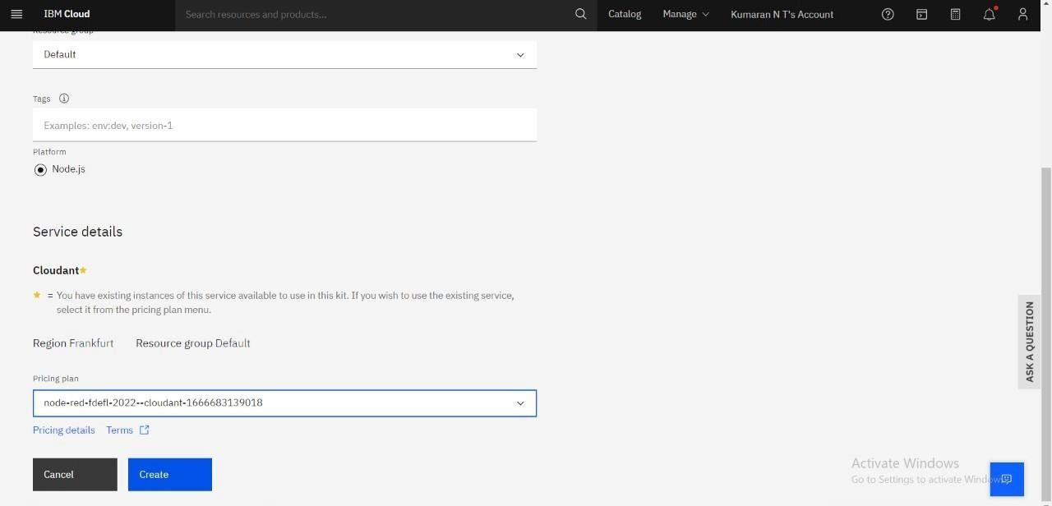

Step 3: Clicking on the “Deploy your App” Button.

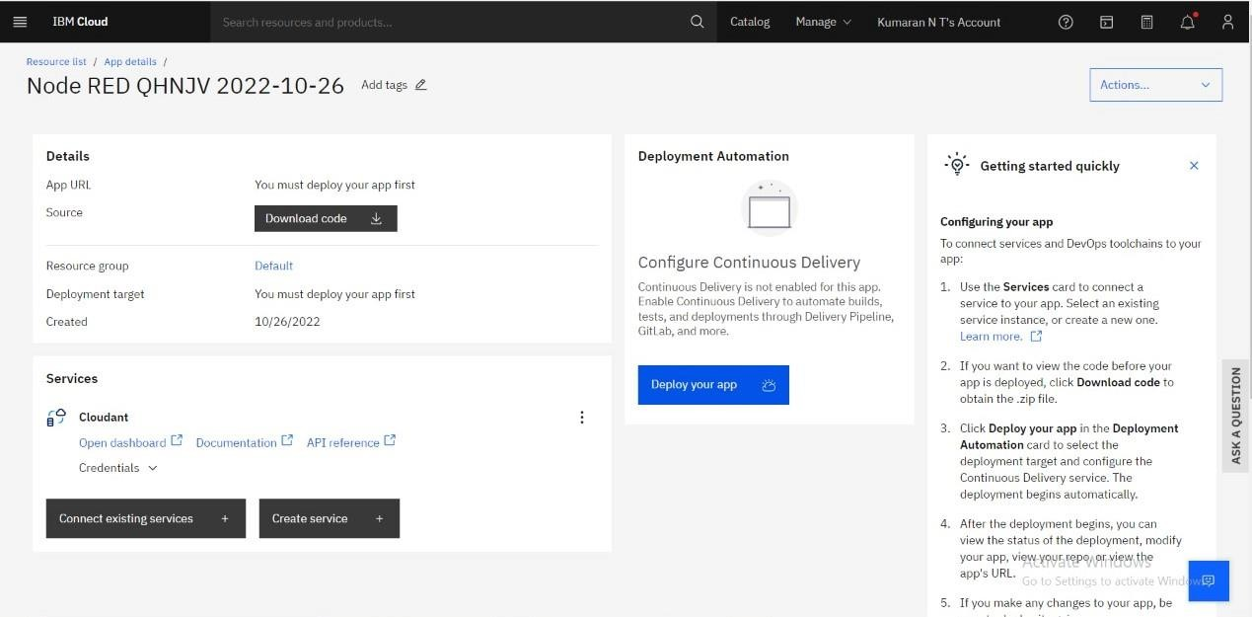

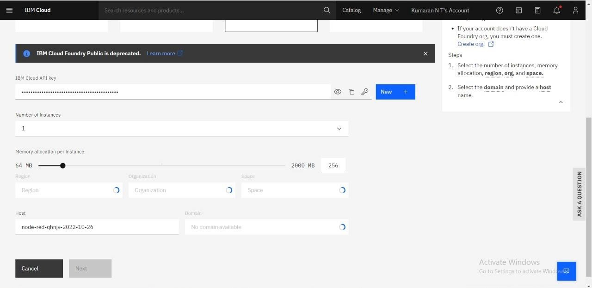

Step 5: Successfully deployed the app.

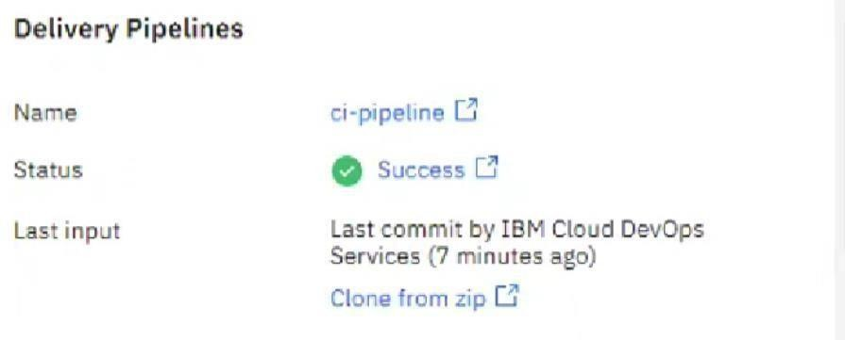

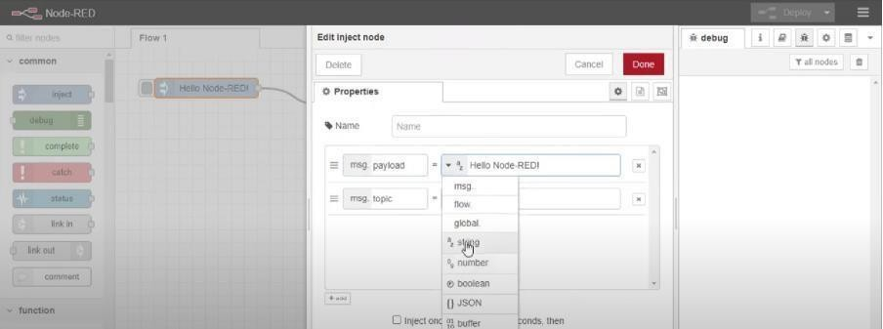

Step 7: Editing some values of the properties.

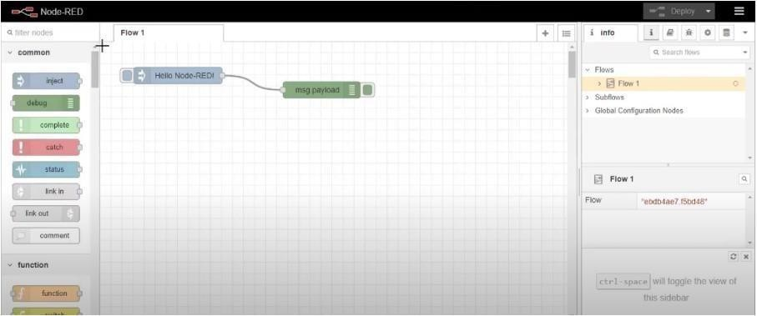

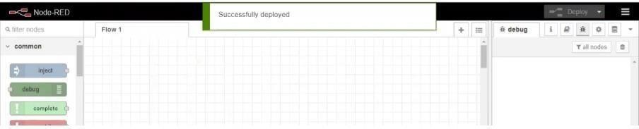

# Result:

Successfully created a Node RED service on IBM Cloud.